**Soft Computing QB**

1. what is computing or computation

Ans : In soft computing, computing or computation refers to the process of performing tasks or solving problems using flexible and adaptive techniques. Soft computing methods are designed to handle complex problems that are difficult to solve using traditional algorithms or methods.

Computing in soft computing can involve a wide range of techniques, including artificial neural networks, fuzzy logic, evolutionary computation, and probabilistic reasoning. These techniques can be used to perform tasks such as pattern recognition, data analysis, optimization, and decision-making.

Soft computing methods often involve learning and adaptation, allowing systems to improve their performance over time as they are exposed to more data or experience. This allows soft computing systems to handle complex and dynamic environments more effectively, making them well-suited for applications such as robotics, image and speech recognition, and natural language processing.

Overall, computing in soft computing refers to the use of flexible and adaptable techniques to perform complex tasks and solve problems in a more effective way.

2) compare hard and soft computing

Ans

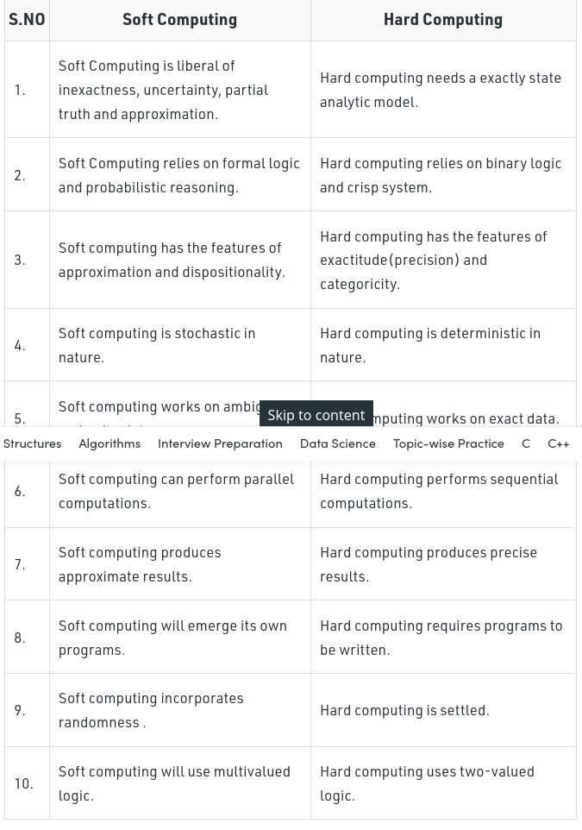

3) what is soft computing and characteristic of soft computing

Ans :Soft computing is the reverse of hard (conventional) computing. It refers to a group of computational techniques that are based on [artificial intelligence (AI)](https://www.javatpoint.com/artificial-intelligence-tutorial) and natural selection. It provides cost-effective solutions to the complex real-life problems for which hard computing solution does not exist.

**Zadeh** coined the term of soft computing in 1992. The objective of soft computing is to provide precise approximation and quick solutions for complex real-life problems.

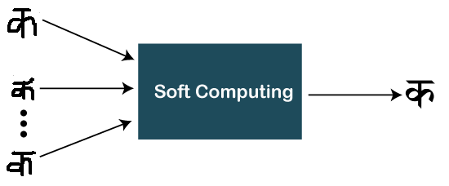

Some characteristics of Soft computing

* Soft computing provides an approximate but precise solution for real-life problems.
* The algorithms of soft computing are adaptive, so the current process is not affected by any kind of change in the environment.
* The concept of soft computing is based on **learning from experimental data**. It means that soft computing does not require any mathematical model to solve the problem.
* Soft computing helps users to solve real-world problems by providing approximate results that conventional and analytical models cannot solve.
* It is based on Fuzzy logic, genetic algorithms, machine learning, ANN, and expert systems.

4) explain any one soft computing technique

Ans : One example of a soft computing technique is fuzzy logic. Fuzzy logic is a mathematical approach to dealing with uncertainty and imprecision in reasoning and decision-making.

In traditional logic, statements are either true or false. However, in real-world situations, many statements are not so clear-cut. For example, the statement "It is hot outside" is not entirely true or false - it depends on the individual's perception of what is considered "hot".

Fuzzy logic allows for more nuanced reasoning by assigning degrees of truth to statements. Instead of just "true" or "false", statements can be assigned a value between 0 and 1, representing the degree of truth. For example, the statement "It is hot outside" might be assigned a truth value of 0.8, meaning that it is mostly true, but not completely true.

Fuzzy logic can be applied to a wide range of problems, such as control systems, decision-making, and pattern recognition. For example, fuzzy logic can be used to control a heating system by adjusting the temperature based on the perceived "hotness" of the environment. Fuzzy logic can also be used in speech recognition, where the system must interpret imprecise or uncertain speech signals.

Overall, fuzzy logic is a powerful soft computing technique that allows for more flexible and nuanced reasoning and decision-making in complex, real-world situations.

5) comapre with diagram auto associative and hetro associative ?

Ans : Auto-associative memory (AAM) and hetero-associative memory (HAM) are two types of neural network architectures used in machine learning and pattern recognition. AAMs are designed to store and retrieve associations between similar patterns, while HAMs are designed to map associations between dissimilar patterns.

An auto-associative memory is a neural network that is trained to learn the associations between similar patterns by creating a mapping between an input pattern and its corresponding output pattern. AAMs are commonly used for tasks such as data compression, denoising, and pattern recognition. The input pattern is fed into the network, and the output of the network is a reconstruction of the input pattern.

Input Layer

|

|

Hidden Layer

|

|

Output Layer

|

|

A hetero-associative memory is a neural network that is trained to learn the associations between dissimilar patterns. In HAMs, there are two separate sets of input and output patterns, and the network learns to map between them. HAMs are commonly used for tasks such as classification, prediction, and pattern matching. Here is a diagram of a hetero-associative memory:

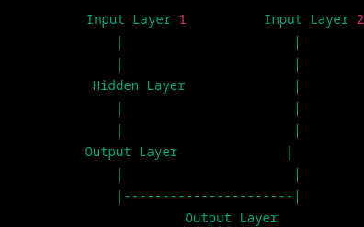

In HAMs, the hidden layer is used to map the inputs from one set of patterns to the outputs of the other set of patterns. The output of the hidden layer is then used to generate the output pattern.

Unit 2

1. explain with diagram biological neural network

Ans : write in book

2) compare biological and artificial neural network ?

Ans

3) what are the different connection architecture of artificial neural network soft computing?

Ans: Artificial neural networks (ANNs) are a type of soft computing system that are designed to mimic the behavior of the human brain. ANNs are composed of multiple layers of interconnected nodes, called neurons, that work together to perform a specific task, such as pattern recognition, classification, or prediction.

There are several different connection architectures that can be used in ANNs, including:

1. Feedforward Neural Networks: In this architecture, the signals flow in only one direction, from input layer to output layer, without any loops or feedback connections. It is the most common type of neural network and is used for tasks such as image recognition and speech recognition.
2. Recurrent Neural Networks: This architecture has feedback connections between neurons, allowing them to remember previous inputs and outputs. Recurrent neural networks are used for tasks such as natural language processing and speech recognition.
3. Convolutional Neural Networks: This architecture is designed specifically for image recognition tasks. It uses a series of convolutional layers to extract features from the input image, followed by pooling layers to reduce the size of the feature maps, and finally, fully connected layers to make predictions.
4. Radial Basis Function Networks: This architecture is used for tasks such as function approximation and data clustering. It uses radial basis functions as activation functions and is trained using a clustering algorithm.
5. Modular Neural Networks: This architecture is composed of multiple smaller neural networks, or modules, that work together to perform a larger task. Each module is trained separately and then combined to create the final network.
6. Deep Belief Networks: This architecture is composed of multiple layers of unsupervised learning algorithms, followed by a supervised learning algorithm. It is used for tasks such as image and speech recognition, and is particularly effective at extracting high-level features from raw data.

4) write note on MP neuarl network ?

Ans : The MP (Multiple Perceptron) neural network is a type of soft computing system that is used for pattern recognition and classification tasks. It is based on the perceptron algorithm, which is a simple, single-layer neural network that can be trained to classify input data into two categories.

The MP neural network extends the perceptron algorithm by combining multiple perceptrons into a single network. Each perceptron in the network is responsible for learning a specific subset of features from the input data. The outputs from each perceptron are then combined to make a final prediction.

The MP neural network is particularly useful for tasks where the input data is complex and high-dimensional, such as image and speech recognition. It is also relatively simple to implement and can be trained using a variety of optimization algorithms, such as gradient descent and backpropagation.

However, the MP neural network has some limitations, such as its inability to handle non-linearly separable data and its tendency to overfit to the training data. These limitations can be addressed by using more advanced neural network architectures, such as feedforward or recurrent neural networks.

5) write the short note on hebb neural network

Ans : The Hebb neural network is a type of soft computing system that is based on the Hebbian learning rule. The Hebbian learning rule states that "neurons that fire together, wire together", meaning that if two neurons are activated at the same time, the connection between them will be strengthened.

In the Hebb neural network, each neuron is connected to every other neuron in the network. The strength of the connections between the neurons is determined by the Hebbian learning rule, which adjusts the weights of the connections based on the correlation between the inputs and outputs of the neurons.

The Hebb neural network is useful for tasks such as pattern recognition and associative memory, as it is capable of learning and recognizing patterns in the input data. It is also relatively simple to implement and can be trained using unsupervised learning algorithms, such as the Hebbian learning rule.

However, the Hebb neural network has some limitations, such as its tendency to overfit to the training data and its inability to handle complex and high-dimensional input data. These limitations can be addressed by using more advanced neural network architectures, such as convolutional or recurrent neural networks.

UNIT 3

explain any 4 types of membership function (diagram on book)

Ans: Membership functions are a key component of fuzzy logic systems in soft computing. They are used to map the input values to a degree of membership in a particular fuzzy set. Here are four types of membership functions commonly used in soft computing:

1. Triangular Membership Function: This membership function has a triangular shape, with a peak at the center and linear slopes on either side. It is often used for variables that have a clear and symmetric range of values, such as temperature or distance.
2. Gaussian Membership Function: This membership function has a bell-shaped curve, with a peak at the center and symmetric tails on either side. It is often used for variables that have a normal distribution of values, such as weight or height.
3. Trapezoidal Membership Function: This membership function has a trapezoidal shape, with a flat top and linear slopes on either side. It is often used for variables that have a range of values that are uncertain or ambiguous, such as the speed of a car.
4. Sigmoidal Membership Function: This membership function has an S-shaped curve, with a gradual rise on one side and a gradual fall on the other side. It is often used for variables that have a range of values that are difficult to define or categorize, such as the level of happiness or satisfaction.

These membership functions can be customized and combined to create more complex and sophisticated fuzzy logic systems for a wide range of applications in soft computing, such as decision-making, control systems, and image processing.

2) problem sums on fuzzy set operations additional operations (book me hai)

3) explain with example basic reshaping operations on fuzzy set?

Ans : Union Operation:

In the case of the [union of crisp sets](https://codecrucks.com/crisp-set-operations/), we simply have to select repeated elements only once. In the case of fuzzy sets, when there are common elements in both fuzzy sets, we should select the element with the **maximum membership value**.

The **union** of two fuzzy sets A and B is a fuzzy set C, written as C = A ∪ B

C = A ∪ B = {(x, μA ∪ B (x)) | ∀x ∈ X}

μC(x) = μA ∪ B (x) = μA(x) ∨ μB(x)

= max( μA(x), μB(x) ), ∀x ∈ X

### **Example of Fuzzy Union:**

C = A ∪ B = {(x, μA ∪ B (x)) | ∀x ∈ X}

A = { (x1, 0.2), (x2, 0.5), (x3, 0.6), (x4, 0.8), (x5, 1.0) }

B = { (x1, 0.8), (x2, 0.6), (x3, 0.4), (x4, 0.2), (x5, 0.1) }

### **Intersection:**

In the case of the [intersection of crisp sets](https://codecrucks.com/crisp-set-operations/), we simply have to select common elements from both sets. In the case of fuzzy sets, when there are common elements in both fuzzy sets, we should select the element with **minimum membership value**.

The **intersection** of two fuzzy sets A and B is a fuzzy set C, written as C = A ∩ B

C = A ∩ B = {(x, μA ∩ B (x)) | ∀x ∈ X}

μC(x) = μA ∩ B (x) = μA(x) ⋀ μB(x)

= min( μA(x), μB(x) ), ∀x ∈ X

### **Example of Fuzzy Intersection:**

C = A ∩ B = {(x, μA ∩ B (x)) | ∀x ∈ X}

A = { (x1, 0.2), (x2, 0.5), (x3, 0.6), (x4, 0.8), (x5, 1.0) }

B = { (x1, 0.8), (x2, 0.6), (x3, 0.4), (x4, 0.2), (x5, 0.1) }

### **Complement:**

Fuzzy complement is identical to [crisp complement operation](https://codecrucks.com/crisp-set-operations/). The membership value of every element in the fuzzy set is complemented with respect to 1, i.e. it is subtracted from 1.

The **complement** of fuzzy set A, denoted by AC, is defined as

AC = {(x, μAC (x)) | ∀x ∈ X}

AC (x) = 1 – μA(x)

### **Example of Fuzzy Complement:**

AC (x) = 1 – μA(x)

A = { (x1, 0.2), (x2, 0.5), (x3, 0.6), (x4, 0.8), (x5, 1.0) }

AC = { (x1, 0.8), (x2, 0.5), (x3, 0.4), (x4, 0.2), (x5, 0.0) }

4) explain the properties of fuzzy set with examples (on book)

## Ans : **Properties of Fuzzy Sets:**

5) write short note on fuzzy logic ? (in a book)

Ans :

6) w.s.n on linguistic variables and hedges? ( this on book)

Ans :

7) explain with examples different types of fuzzy propositions (in book)

Ans :

8) explain the different types of fuzzy quantifiers ? (https://youtu.be/7gkiSKiZa9A)

9) explain with example alpha-cut.?

Ans : This is on book